User Manual for thePrototype

short line

Huawei - USC  
July, 2018

# Introduction

This document

1) suggests an operational workflow for demonstrating the prototype based on Architected Agile process and TR4 milestone.

2) gives a demo of the Risk Prediction API and it query format.

This prototype makes supplement to the slides and shows how the risk prediction model connects to the expert system, such that it can redirect to different activities based on the level of runtime risks.

# 

Go to the [Factor Input Page](http://ec2-54-67-99-52.us-west-1.compute.amazonaws.com:8686/demo/phase5/start/factorsInputPage.html) or hit the following link,

http://ec2-54-67-99-52.us-west-1.compute.amazonaws.com:8686/demo/phase5/start/factorsInputPage.html

# Step 1

**Select a Product Type** and **adjust the value for each factor**. 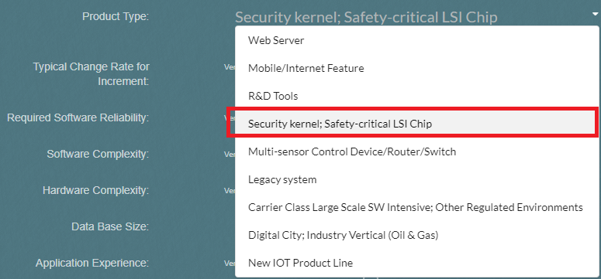

For example, we can set “Software Complexity” to “Extra High”, set “Hardware Complexity” to “Extra High”, set “Application Experience” to “Very low” and get the values as following.

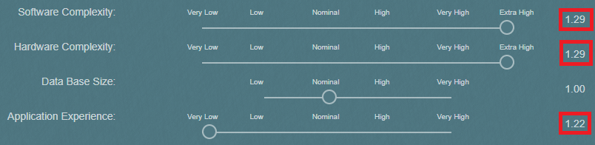

More detail of the current active factor will be shown on the top of this interface to help the user to make decision.

# Step 2

**Click “Next”** to set the project size. We can leave it as default value in this demo.

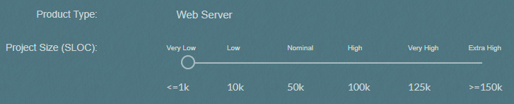

**Click “Estimate”** to get the cost estimation result from COCOMO

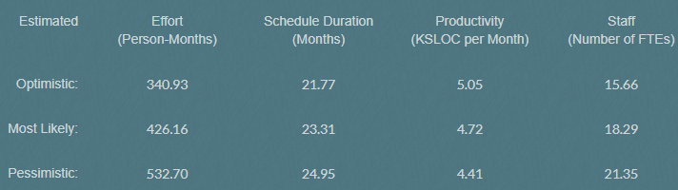

# Step 3

**Click “Start” to the KPI Evidence Dashboard**. In this demo connected to “TR4”, under “Verification” Phase, click the **button with a “calculation” icon** for each KPI item, the system queries the current KPI status from DNA server (based upon OrientDB)

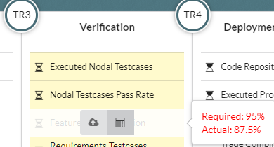

# Step 4

**Click “Show Workflow”** on the top of the page, we come to the “Project Management Dashboard” which list the current tasks for each role involved in a project.

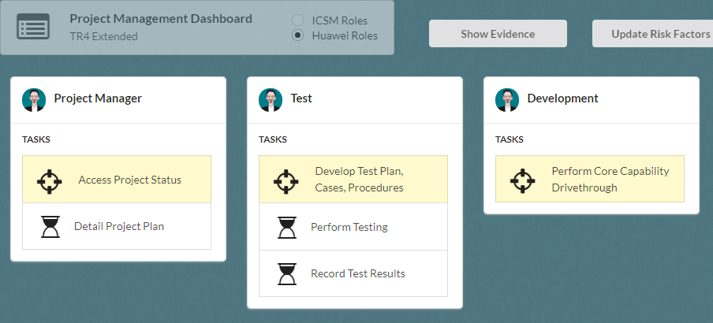

# Step 5

Go ahead to **“Complete” those tasks** related to testing and come to the “**Transition Readiness Review**”, which is the anchor point of the process in this demo.

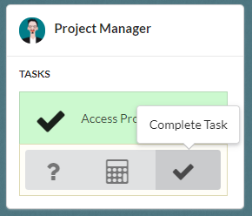

**5. 1** During this process, we can **click “Show BPMN”** button on the top right of the page to view the currently active BPMN diagram.

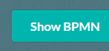

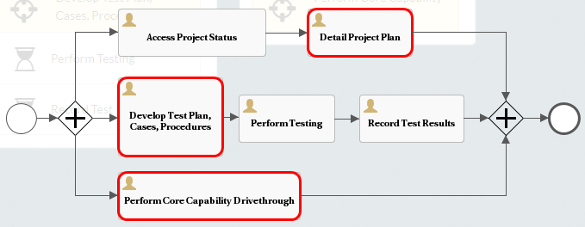

**5.2 Click “Calculate Risk”** on the currently active task to redirect to risk assessment interface which assists to figure out the risk level.

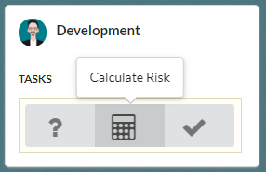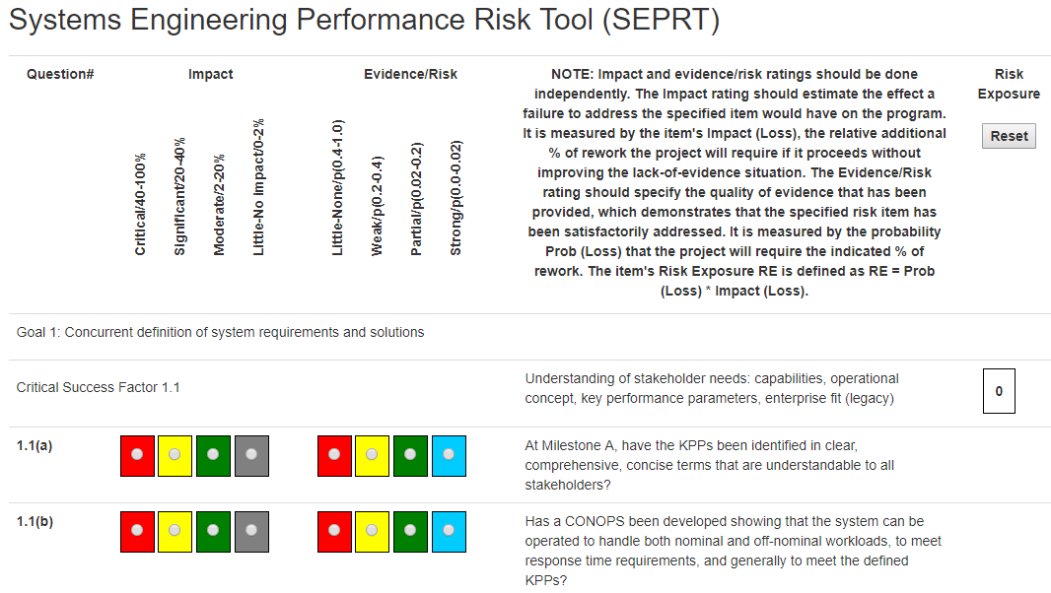

# Step 6

With the “**Transition Readiness Review**” task, **click “Complete Task”**. The system gathers current settings (e.g. risk factors) and queries Risk Prediction API for analysis.

After analyzing, the Risk Prediction Engine helps to work out the risk level and the priority of suggested actions. We can **select the expected actions** and **click “Accept”** to follow system’s suggestion. For example, we can “Accept” to “**Update Project Plan and Milestone**”.

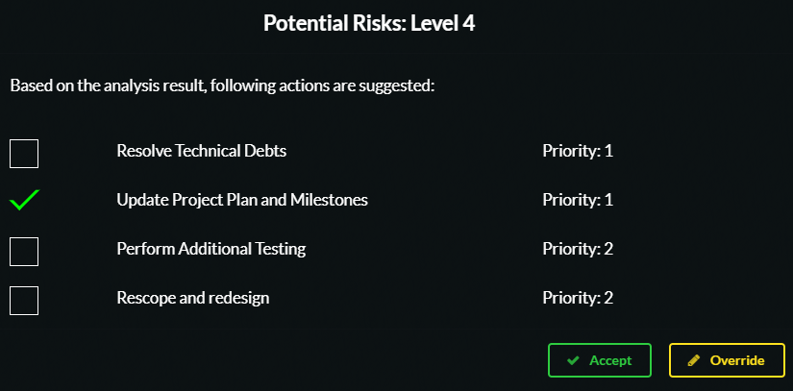

Different activities will be triggered according to our selection, and the tasks then will change. we can click “Show BPMN” to view the new BPMN workflow of selected activities.

# Step 7

**Click “Update Risk Factors”** on the top of the page, we can go to the “Factor Input” interface again.



**Adjust the values** for each factor. For example, this time, we can reduce the level or “Software Complexity” and “Hardware Complexity” and increase the level of “Application Experience”.

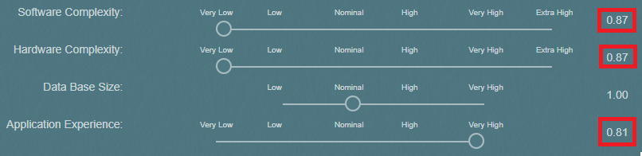

Then **click “Next” - > “Estimate” -> “Start” to back to the “Project Management Dashboard”**

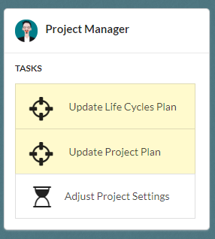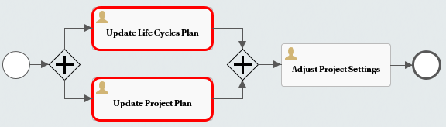

# Step 8

After “Complete” all tasks, we come to the task of “Transition Readiness Review” again. The system will query the current risk level from Risk Prediction Engine based on the current settings. Our current setting shows the predicted risk level is reduced.

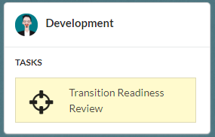



# Step 9

In addition to Step 6, if we don’t want to “Accept” the system’s suggestion but insist to go on with the process, we just click “Override”. Then the “Transition” activity will be triggered.

Open BPMN diagram and see what happens.

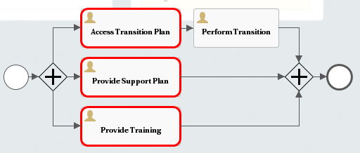

short dash

# Risk Prediction Model API Prototype

# Step 1

Input URL: [*http://ec2-54-67-99-52.us-west-1.compute.amazonaws.com:808*](http://ec2-54-67-99-52.us-west-1.compute.amazonaws.com:8081)*1* to load the Risk Prediction Model API Prototype Page.

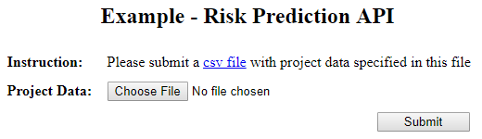

# Step 2

Upload a csv file including the data according to the defined factors, which can also be downloaded from the link given in the above figure.



# Step 3

View the risk prediction results given by the model.

